Santos A. Mejia Ayala

Stat 333 Bodyfat Project Summary
This linear regression model is about a study collecting body fat percentage alongside several other metrics, including wrist size, waist size, age, weight, etc. In our model, I decided to exclude underwater density from consideration as a predictor variable as underwater density can be used to directly calculate body fat, which makes using it as a predictor variable circular, and it’s not a good rule of thumb due to the great inconvenience it is to measure. As per the guidelines, I chose to prioritize rule of thumb, accuracy, and simplicity, trying to find a balance between a convenient rule of thumb, understandable interpretability, and predictive power.
During the data cleaning and review, I got rid of the identifiers unnecessary to our model, such as the identifier which merely counted the observations. I also erased any potential unrealistic body fat percentage values, specifically <0 and >60, and checked the columns for any potential missing values, as in I checked to see if any people in our dataset had some measurements relevant to our study not taken (none were missing).
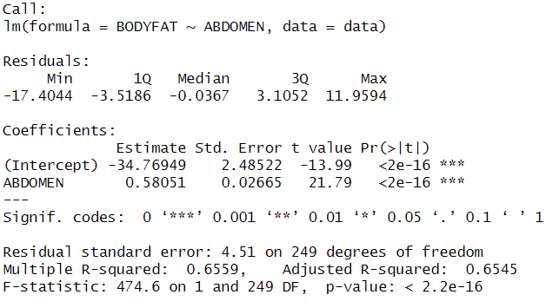
To start off, I examined a simple linear regression, that being Bodyfat = B0*Abdomen:

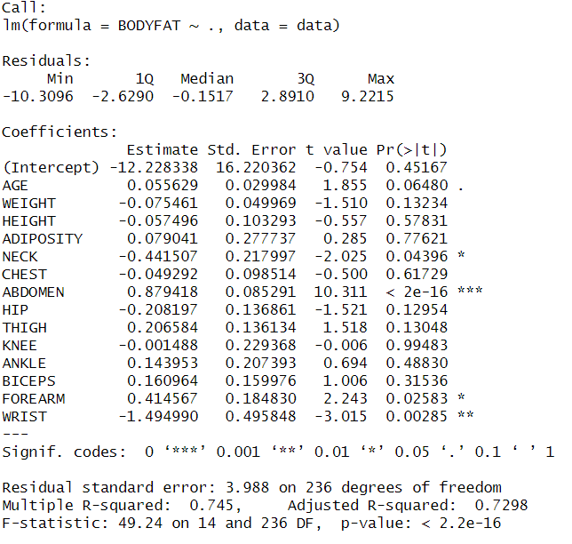
For comparison, here’s the full model:

In the simplest model with our most significant predictor variable, we find incredible simplicity and easy interpretation, although we lose about 7% of the variability we could account for. Moreover, after using an anova table, we see there are other significant variables with an alpha of .05.
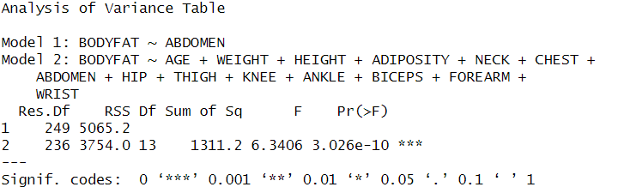
With this info, I constructed a more complicated model which contained all significant variables, and I ended up with Bodyfat = B0*Abdomen+B1*Weight+B2*Wrist:
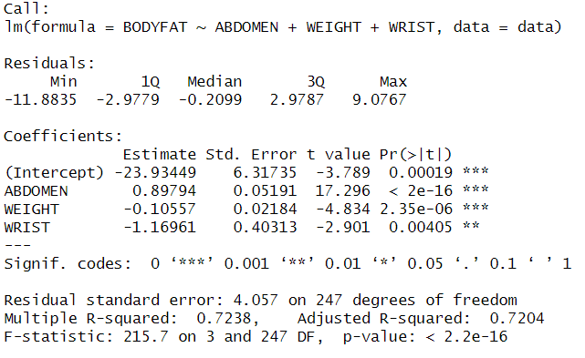
The table shows this new model had an adjusted R^2 value of .7204, which less than 1% of variability that was accounted for in the full model no longer accounted for with this reduced model. Moreover, the analysis of variance table with this model and the full model suggests all other variables are not statistically significant. I did also experiment with removing some of these variables, and removing even a single one leads to a statistically significant decrease in model fit, using an alpha of .05.
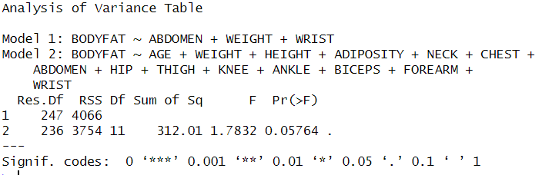
Referring to the summary above, we see a positive correlation between body fat percentage and abdomen measurement, and a negative correlation between body fat percentage and both wrist size and weight, although the influence of weight is noticeably smaller. One can interpret this as people with higher abdomen size, controlling for all other variables, tend to have a higher body fat percentage, while people with lower weight, (and lower wrist size similarly) controlling for all other variables, tend to have lower body fat percentage. It’s worth noting wrist size is an indicator of body frame (especially bone structure). It might seem counterintuitive to suggest smaller weight and wrist size correlates negatively with body fat percentage, but consider that all other variables are held constant. A person with similar build and abdomen size which weighs more will have a denser body, and since body fat is the least dense tissue in the body, it suggests the increased presence of denser tissues like muscle or bone compared to fat. Similarly, two people with similar abdomen size and weight that differ in body frame (measured by wrist size, one of the boniest parts of our bodies) will likely have differing body fat percentage, lower body fat percentage for the larger frame since more of that size is bone.
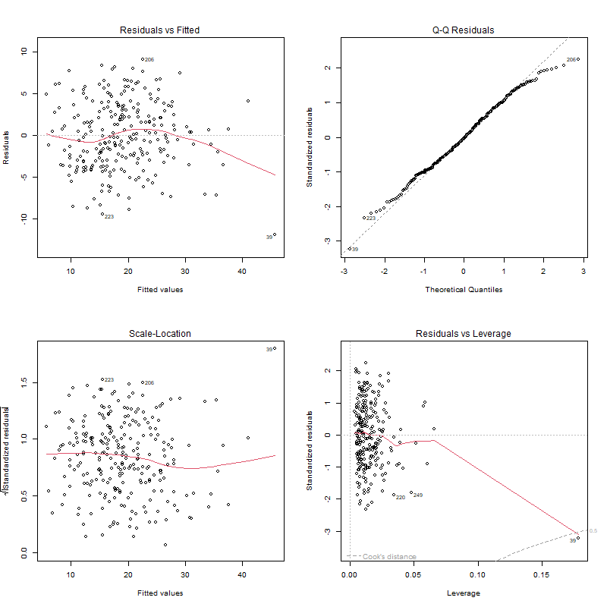
It’s worth noting this model, although still meeting all requirements for both accuracy, simplicity, rule of thumb, and interpretability while upholding all linear regression assumptions, (homoskedasticity, normality in variance, no major pattern in residual plot, no major deviation in qq plot as seen below), was not found systematically, but through trial and error. While it worked for this specific instance, it is not the recommended approach due to how time-consuming and prone to error searching for the best linear regression manually is.
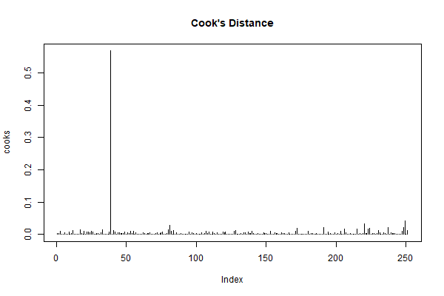
There is one outlier as seen in the Cook’s distance plot, but after further analysis, it was observed to not produce any change in interpretation nor does it affect the adjusted R^2 significantly, so it was included in our data.
In conclusion, the multiple linear regression model Bodyfat = B0*Abdomen + B1*Weight + B2*Wrist was judged to be the optimal balance between a simple easy rule of thumb and an accurate predictive model. Abdomen correlates positively with body fat percentage, while weight and wrist size correlate negatively with body fat percentage, holding all other variables constant respectively. Much analysis was done, and this reduced model accounts for nearly as much variability as the full model, upholds all linearity assumptions, and includes only and all significant variables pertaining to our data set. Rule of thumb: Body fat percentage can be estimated primarily from abdomen size with adjustments for mass and frame size.

References

SMA: data cleaning, model building, diagnostics, writing, presentation

